**LockedMe.com**

A simple file handling project in Java

**Flow Chart**

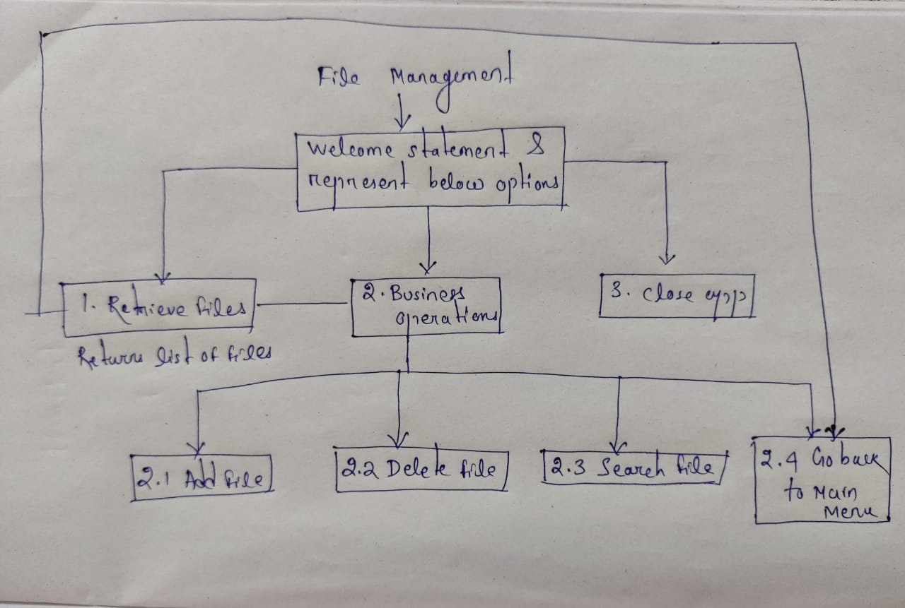

**Using the application**

1.Welcome screen displays the application name and the developer details.

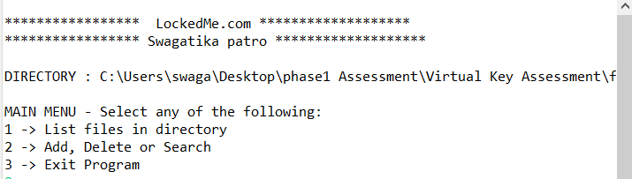

2. The details of the user interface are shown to the user. The user has to select from the options listed

A. The first option returns the current file names in ascending order. The main directory can be assigned in LockedMe class.

B. The second option returns the details of the user interface options displaying the following:

* Add a file to the existing directory list
* Delete a user specified file from the existing directory list
* Search a user specified file from the main directory
* Option to navigate back to the main context

C. Third option to closes the application

3. Project is created with:

* Java version 17
* IntelliJ IDE

4. Run this as a java program.

GitHub Link:::: https://github.com/patroswagatika/Phase1-Assessment.git